Opened it using ng s
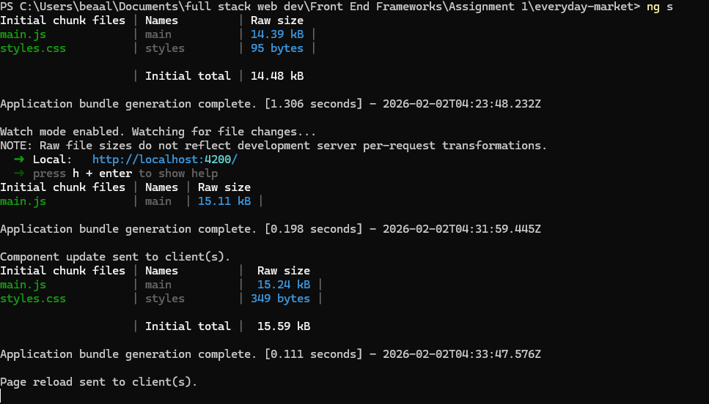
This is my homepage
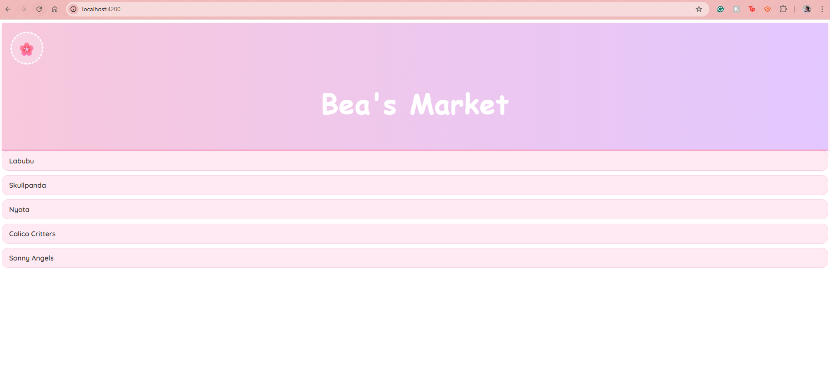
I clicked “Labubu” and this is what shows up
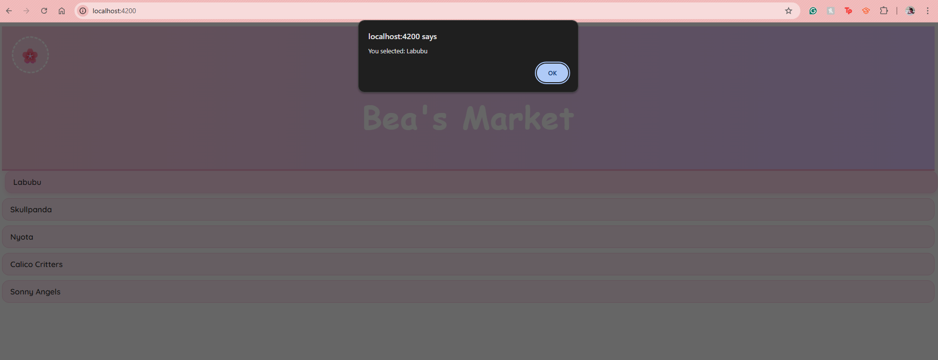
I also added a hover effect to it just to be a little bit more fancy
I clicked “Skullpanda” and this is what shows up
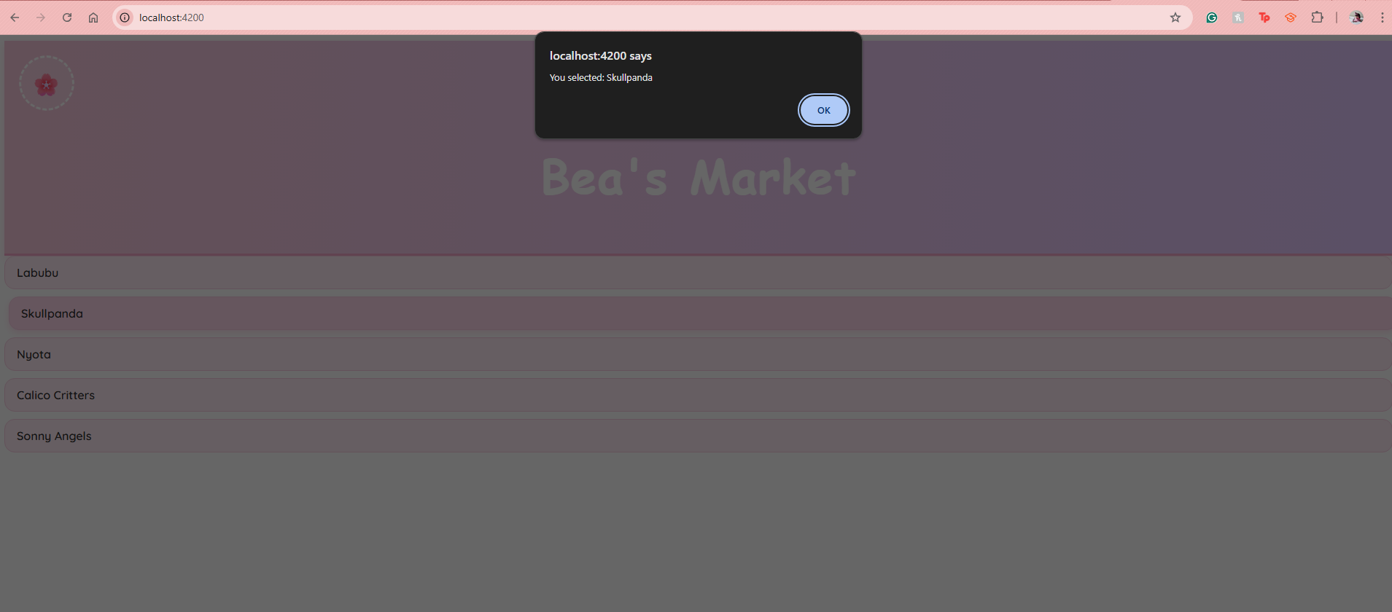

I clicked "Nyota” and this is what shows up
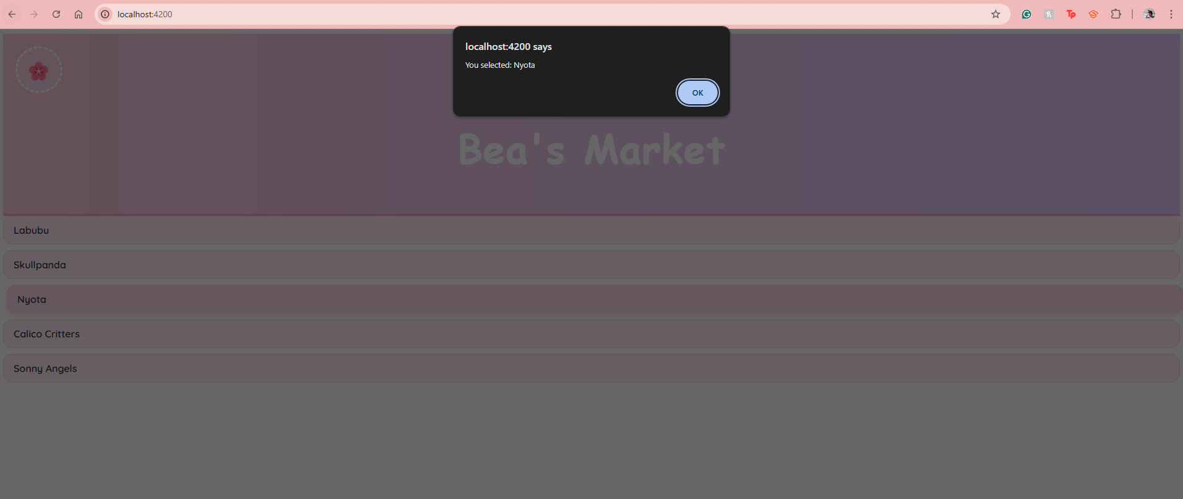
I clicked "Calico Critters” and this is what shows up
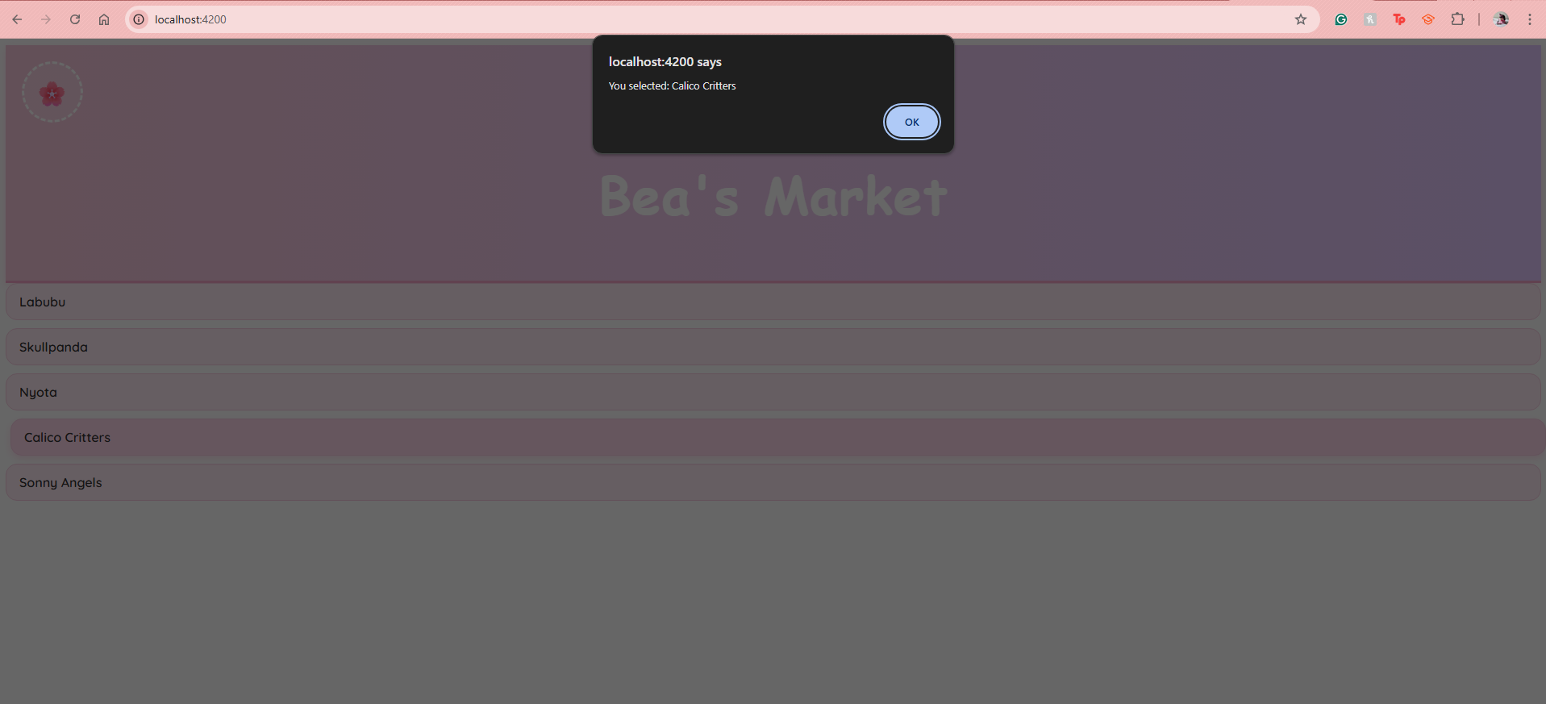

I clicked "Sonny Angels” and this is what shows up
